
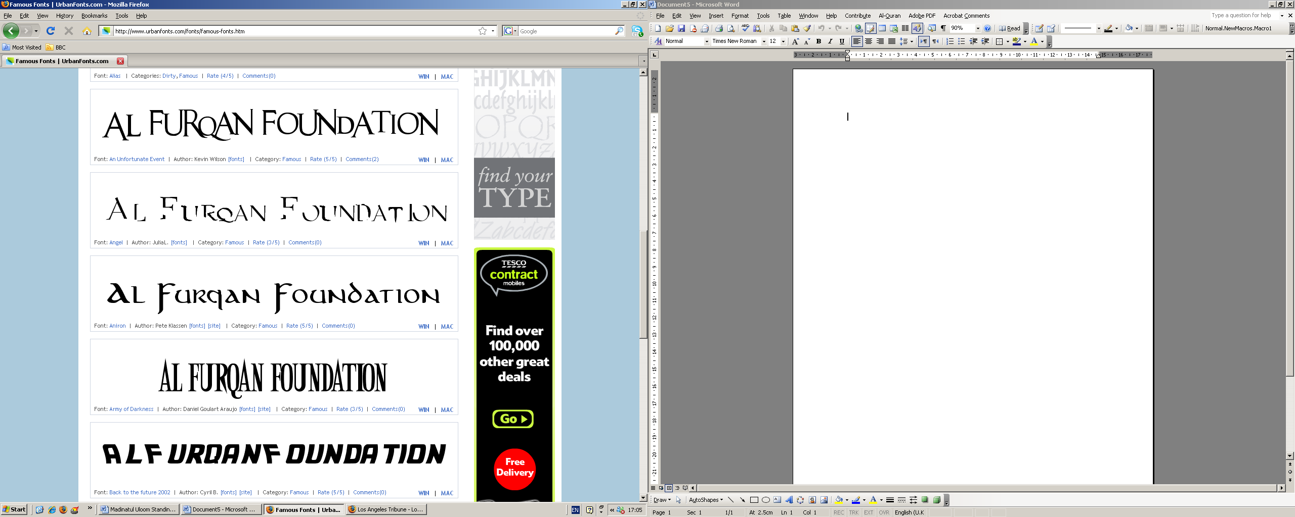

Dear Bank Manager, please debit from my account below the amount of £……………… Per month starting from ___ /___ /___ until further notice, to the benefit of :

Al furqaan foundation
Barclays Bank, Sort Code: 20-12-21, Account No.: 60361232
MY DETAILS:

Name (of account holder):

Home Address:

Town/City: Post Code:

Telephone/Mobile No.:
MY BANK DETAILS:

Bank Name:

Sort Code:

Account No.:

Signature ……………………..……………………………………… Date …………………………….
GIFT AID – Make your Donations go further by adding 28% to your gifts free
I am a tax payer and I would like Al furqaan foundation to reclaim tax on all
Donations I have made since 06/04/2001 and thereafter until further notice, as gift aid donations.
Please send to: PO BOX 9721 Brentwood CM149DG, or email us al_furqan_foundation@hotmail.co.uk To arrange collection
STANDING ORDER MANDATE

Dear Bank Manager, please debit from my account below the amount of £……………… Per month starting from ___ /___ /___ until further notice, to the benefit of :

Al furqaan foundation
Barclays Bank, Sort Code: 20-12-21, Account No.: 60361232
MY DETAILS:

Name (of account holder):

Home Address:

Town/City: Post Code:

Telephone/Mobile No.:
MY BANK DETAILS:

Bank Name:

Sort Code:

Account No.:

Signature ……………………..……………………………………… Date …………………………….
GIFT AID – Make your Donations go further by adding 28% to your gifts free
I am a tax payer and I would like Al furqaan foundation to reclaim tax on all
Donations I have made since 06/04/2001 and thereafter until further notice, as gift aid donations.
Please send to: PO BOX 9721 Brentwood CM149DG, or email us al_furqan_foundation@hotmail.co.uk To arrange collection
STANDING ORDER MANDATE

